How to Access the WIN 2024 Game Schedule
DOWNLOAD THE TEAMSNAP TOURNAMENTS APP to see game schedules, alerts, and real-time scores.

To download the TeamSnap Tournaments app, go to the Google Play Store or Apple App Store to find app:

1. Google Play Store - https://play.google.com/store/apps/details?id=com.fanapp

2. Apple App Store - https://appsto.re/us/1ngndb.i

3. In the App, sign in using your email address and follow our tournament, WIN 2024

4. Now you can see your favorite team, see division schedules, and receive real-time scores, updates, and notifications.

WEB ACCESS TO GAMES:
You can also see results on the web here. Please note that you will not receive real-time alerts unless you are on the app. https://events.teamsnap.com/events/32291/results/division

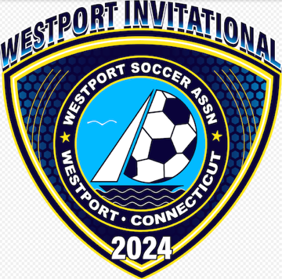

Questions? Contact: registrar@westportsoccer.org

WIN 2024 Website: www.wintournament.net

